Ballymacward
Primary School

Anti-Bullying Policy
Reviewed On: September 2019
Next Review Date: June 2020

- Status: Version 2

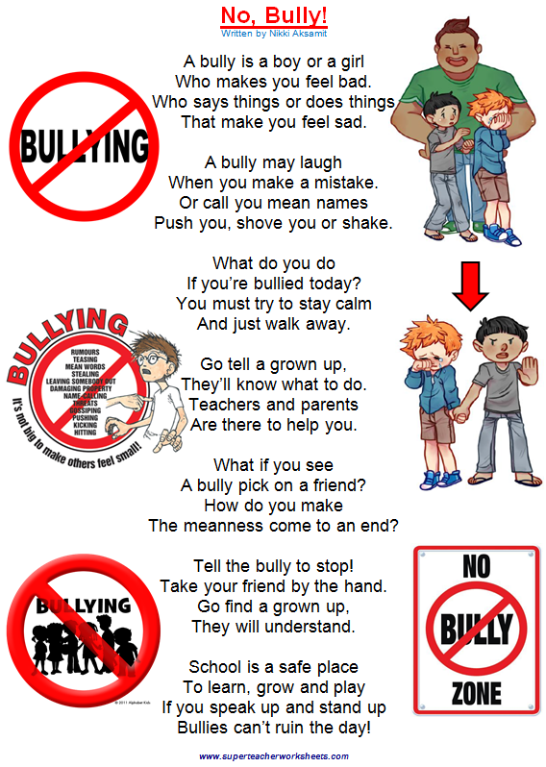

Introduction

The governors and staff of Ballymacward Primary School are completely opposed to bullying and will not tolerate it. It is contrary to the values and principles we live by. All members of the school community have a right to work in a secure and caring environment. They also have a responsibility to contribute in whatever way they can to the protection and maintenance of such an environment.

Definition of Bullying

“Bullying is aggressive or insulting behaviour by an individual or group,
often repeated over a period of time, which intentionally hurts or harms.”

The three main types of bullying are:
- Physical - hitting, kicking
- Verbal - name calling, racist or homophobic remarks
- Indirect - spreading rumours, excluding someone from social groups, spreading nasty stories, cyber bullying (bullying via mobile phones or the internet) or writing offensive graffiti.

Bullying is never the bullied child’s fault. A bullied child may display some of the following behaviours;

Angry Anxious Depressed Sick Isolated

Shy Disturbed sleep patterns Vulnerable

It is important to note that bullies have their own problems. They feel upset or angry or feel that they don’t fit. Perhaps they have problems at home. The needs of both bully and victim must be addressed to remedy the situation.

The Aims of our Anti-Bullying Policy

- To maintain a secure, safe and happy environment for all our children and staff
- To prevent, as far as humanly possible, bullying in any form
- To deal consistently and promptly with any incidents of bullying that may arise

Reluctance to Report Bullying

It is important to appreciate that many pupils are reluctant to make an immediate report of an incident of bullying. This may be due to a number of reasons, such as fear of reprisals, feelings of low self-esteem, guilt, embarrassment or fear of not being believed. It is therefore essential that all members of the school and home community take responsibility for raising awareness.

The success of our anti-bullying policy depends on the roles and responsibilities of staff, pupils and parents.

Responsibilities of all Staff
- The staff will foster in our pupils, self-esteem, self-respect and respect for others.
- Demonstrate by example the high standards of personal and social behaviour we expect in our pupils.
- Discuss bullying with all classes so that every pupil learns about the damage it causes to both the child who is bullied and to the bully, and the importance of telling a teacher about bullying when it happens.
- Be alert to signs of distress and other indications of bullying.
- Listen to children who have been bullied, take what they say seriously and act to support and protect them.
- Report suspected cases of bullying to a member of the Safe Guarding Team.
- Keep records of reported incidents in class Record of Concern book and where there is a repeated incident of bullying, report the matter promptly to Mr Sadlier (Principal & Deputy Designated Teacher for Child Protection) or Mrs Yakdan (Designated Teacher for Child Protection).
- Follow up any complaint by a parent about bullying and report back promptly and fully on the action that has been taken.
- Deal with observed instances of bullying promptly and effectively in accordance with agreed procedures.
- Use circle time and school assemblies to promote opportunities to discuss the subject.
- Display posters around the school to combat bullying.
- Promote “Buddy system”
- Classroom assistants and teachers on duty should be vigilant in looking for signs of bullying.
- They should report any incident of bullying or suspected bullying to the class teacher or in the absence of the teacher, Mr Sadlier or Mrs Yakdan.
- During lunch times supervisory staff will assist with playground games and help maximise the use children make of the play equipment and playground markings. They will closely monitor children’s involvement in activities.

Procedures for dealing with incidents of bullying

When an incident of bullying is reported to a teacher the following procedure is followed:
- Listen carefully to all the pupils involved;
- Record all details in the Record of Concern Book;
- Assure the victim that the matter will be dealt with as quickly as possible;

Responsibilities of Pupils

We expect the pupils to:
- Not suffer in silence if they should become the victims of bullying;
- Refrain from becoming involved in any form of bullying;
- Report to a member of staff any witnessed or suspected instances of bullying;
- Intervene to protect the pupil who is being bullied by reporting the incident to an adult.

Advice to parents

- Find out the facts.
- Reassure your child that you will do everything you can to sort out the problem.
- Make sure your child knows that bullying is wrong and that no-one deserves to be bullied.
- Stress that he/she needs to tell the truth.
- Accept what your child is saying and allow him/her plenty of time to explain what is happening.
- Write down all facts and explain to your child that you will need to contact the school.

You may wish to speak to the Principal or the Class Teacher. A parent making a complaint about bullying will have a personal response from the Principal or the Designated Teacher, Miss Devlin, indicating the investigation which has been carried out and the action being taken.

The curriculum and other preventative measures

Our curriculum encourages the development of positive relationships and aims to prevent any form of bullying in the school and in the wider community. We do this mainly through Health Education, PDMU, RE and RSE.

Strategies adopted by the school include:
- The school ethos
- The school mission statement and aims of the school
- The general school environment
- Supervision at lunchtimes, breaks, before and after school
- Supervised internet access and filtered access (C2K).
- The use of assemblies to raise awareness
- Participation annually in ‘Anti-Bullying Week’ activities (November)
- Circle time
- School Council
- Playground Buddy Base System
- ‘Goody Box’ monthly awards.
- Pupil and Teacher promises
- School Code Ode

Pupils will be informed that Mrs Yakdan is the Designated Teacher for child protection and given the opportunity to approach her at any time.

